Biology
Standard: B4B (readiness) | 3.0 Items
Investigate and explain cellular processes, including homeostasis, energy conversions, transport of molecules, and synthesis of new molecules. and synthesis | Option one:(short answer)  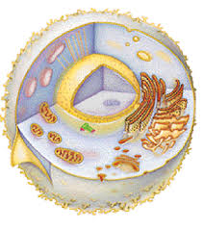  - Explain the different processes that occur in the cell above.  - Diagram and label an image that represents how the cell membrane regulates homeostasis.  - Explain a step by step process of how proteins are made in a eukaryotic cell.  - Explain how and where energy is processed in a Eukaryotic cell.  Option 2( more broken down needs something???)  Match the cellular process with the product.  1.Homeostasis  2. Energy  3. Protein  - Osmosis  - Protein Synthesis  - Cellular Respiration  Option 3: (leaves out information but could have more questions added like this or with this concept)  4..During lab over osmosis two students concluded different results for homeostasis. Which Conclusion is correct?  - The cell membrane helps to regulate water movement in and out of the cell. This helps to maintain homeostasis. This was observed when the grape in a sugar solution shrank and in distilled water the grape swelled.  - The cell membrane helps to regulate water and sugar movement in the cell. This helps to maintain homeostasis. This was observed when the grape in a sugar solution swelled and in distilled water the grape shrank.
 | 2.0 Items
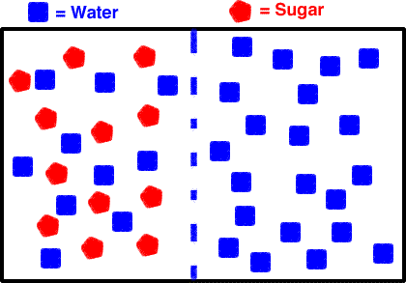

- Which statement best describes what will happen in the model above.
  - The sugar will pass through the membrane creating a hypertonic solution.
  - The water will pass through the membrane to create an isotonic solution.
  - The membrane is impermeable and the solution will not change.
  - The water will pass through the membrane to create a hypotonic solution.

2. Select all potential organelles that are directly responsible for the creation of new molecules
- Nucleus
- Endoplasmic Reticulum
- Ribosomes
- Mitochondria
- Vacuoles
- Cell Membrane
- Golgi Apparatus
- Nucleolus
- Lysosomes

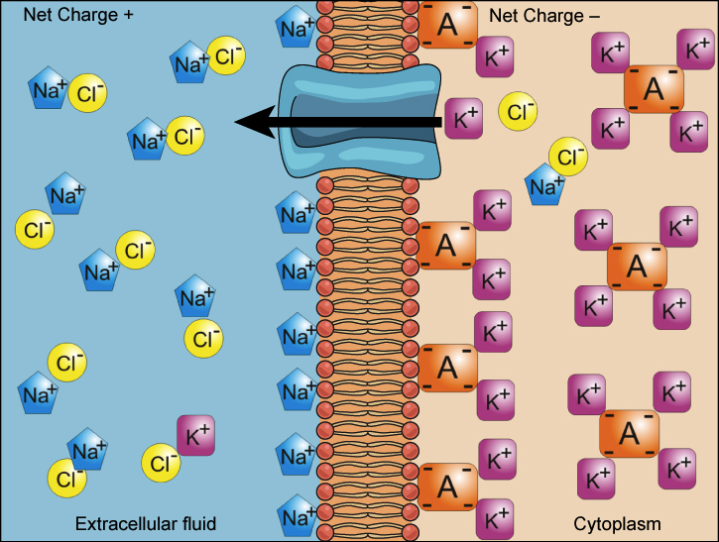

3. Which organelle would be responsible for creating the ATP needed to move the potassium molecule.
- Cell Membrane
- Nucleus
- Mitochondria
- Ribosomes

4. Using the word bank fill out the chart below

 | Photosynthesis | Respiration
Where?
When
Reactant?
Product?
Energy Source
Energy Result

Word Bank:
Chloroplast
Mitochondria
All the time
Presence of light
Glucose and Oxygen
Carbon Dioxide and water
Light
Chemical Bonds
Energy stored
Energy Released

Standard: B9A (readiness) | 3.0 Items
Compare the structures and functions of different types of biomolecules including carbohydrates, lipids, proteins, and nucleic acids. | Match the structure to the function  1 - Contains Genetic Information  2 B. Storing energy, signaling, and acting as structural components of cell membranes  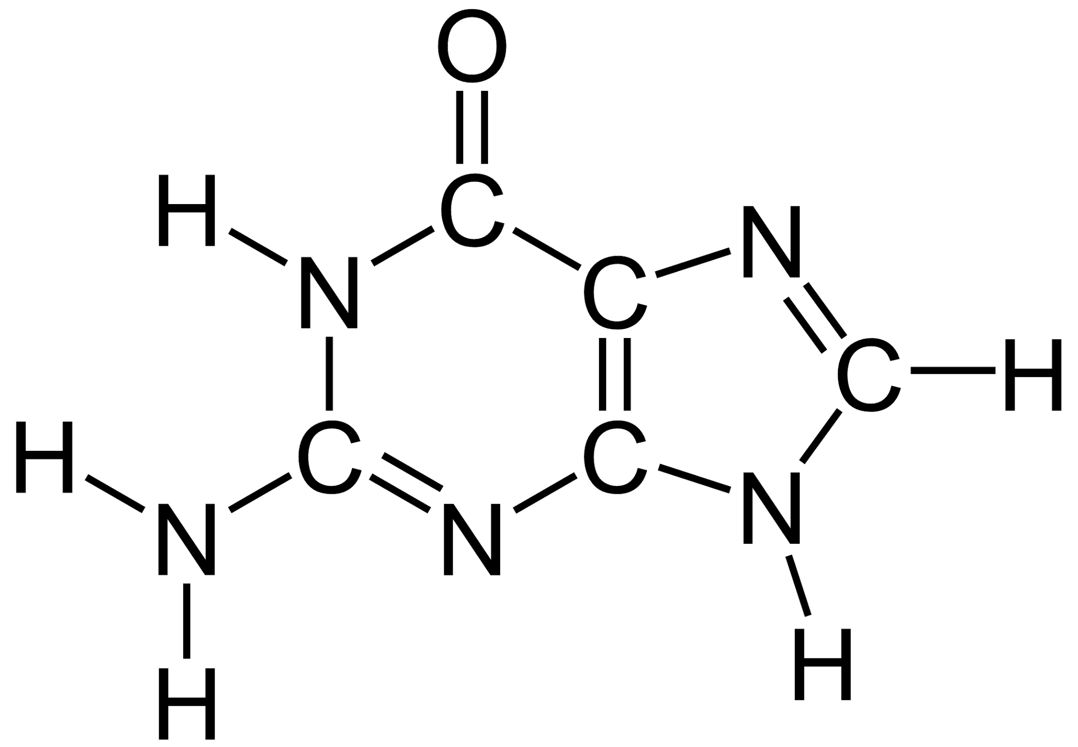3 C. Providing energy and regulation of blood glucose.  4 D.structure, function, and regulation of the body's tissues and organs
 | 2.0 Items
- Select all the elements found in common in all four biomolecules.
  - Nitrogen
  - Carbon
  - Hydrogen
  - Chlorine
  - Oxygen
  - Phosphorus

2. Body Builders who need to build muscle must increase which biomolecule in their diet?
- Carbohydrates
- Protein
- Lipids
- Nucleic Acid

3. Which Biomolecule plays an important role on organisms who live in cold harsh environments?
- 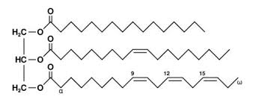
- 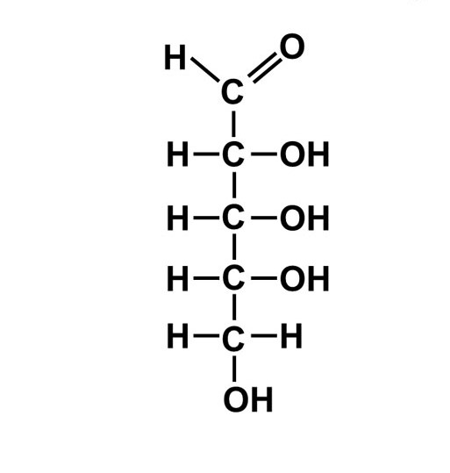

c.
d. 